无心磨床
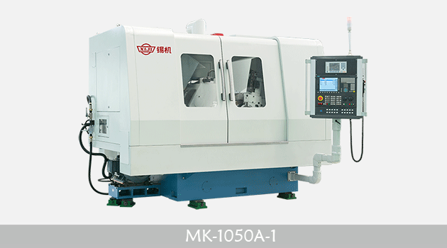
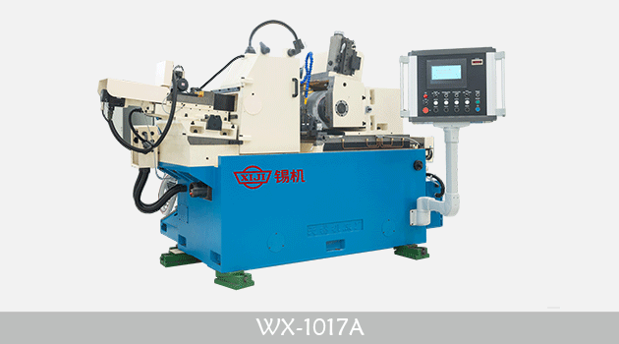
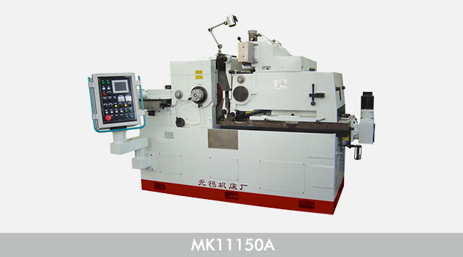
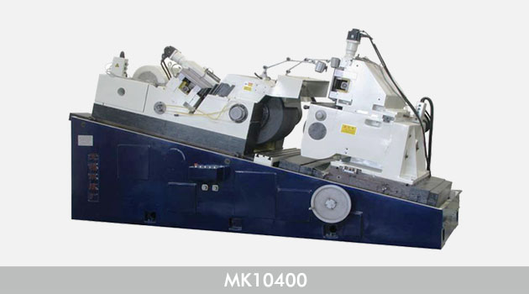
适用于各类圈类、轴类及管类零件的圆柱面进行通过式磨削和对各类阶梯、锥形、圆柱体旋转面进行切入式磨削等。磨削直径范围：0.5mm——400mm;圆度范围：0.001m——0.006mm;直径一至范围：0.002mm——0.008mm;粗糙度范围：Ra0.016——Ra0.64
产品型号 | 磨削直径  通磨/切入磨(mm) | 磨削长度  通磨/切入磨(mm) | 加工精度(μm) |  |  | 总功率  (kw) | 机床重量  (kg) | 外形尺寸  (cm) | 备注
 |  |  | 圆度 | 圆柱度 | 粗糙度(Ra)
M1020A | 0.5~20/3~20 | 80/80 | 2 | 2 | 0.32 | 5.3 | 1900 | 175×129\0
MG1020 | 0.5~20/3~20 | 80/80 | 1 | 1.2 | 0.16 | 5.57 | 2000 | 180×215\0 | 高精度
MT1040A | 2~40/7~40 | 140/120 | 2 | 3 | 0.32 | 8.83 | 2000 | 155×130\0 | 切入磨特殊订货
MM1040S | 1~40/2~40 | 140/120 | 1.5 | 2 | 0.20 | 10.23 | 2000 | 155×130\0 | 精密数控一轴
M1050A | 5~50/7~50 | 120 | 2 | 3 | 0.32 | 13.78 | 2800 | 192×168\0
MG1050B | 5~50 | 200/145 | 1 | 1.5 | 0.16 | 16.83 | 5000 | 355×270\0 | 高精度、数控
MGT1050 | 2~50 | 180 | 1 | 1.8 | 0.16 | 11.59 | 5000 | 220×119\0 | 高精度、通磨
MK1050 | 2~50/5~50 | 195 | 0.6 | 1 | 0.20 | 25 | 5000 | 240×130\0 | 数控
WX3-018 | 2~50 | 200 | 1 | 1.5 | 0.16 | 13.7 | 3000 | 221×124\0 | 高精度
WX3-018/1 | 2~50/5~50 | 200 | 1 | 1.5 | 0.16 | 14.2 | 3000 | 229×120\0 | 数控
WX3-018CNC5 | 2~50/5~50 | 200 | 1 | 1.5 | 0.16 | 25 | 3000 | 229×120\0 | 全自动
M1080D | 5~80 | 180/145 | 2 | 3 | 0.32 | 16.68 | 3500 | 195×158\0
MKS1080 | 5~80 | 200/145 | 2 | 3 | 0.32 | 18 | 5000 | 340×206\0 | 高速、数控
M10100 | 10~100 | 210/195 | 2 | 3 | 0.32 | 20.16 | 5000 | 267×150\0 | 切入磨特殊订货
M10100B | 10~100 | 210/195 | 2/3(切入) | 3/5(切入) | 0.32 | 20.96 | 5000 | 267×150\0 | 数控
MS10100 | 10~100 | 195 | 2 | 3 | 0.32 | 36.66 | 7500 | 340×142\0 | 高速
MKS10100 | 10~100 | 240 | 2 | 3 | 0.32 | 36.6 | 7500 | 340×142\0 | 高速 、数控
MKG10100 | 10~100 | 195 | 1 | 2 | 0.16 | 25.8 | 7000 | 328×130\0 | 高精度、数控
MW10200 | 10~200 | 300/290 | 2 | 4 | 0.32 | 47 | 10000 | 367×155\0
MW10200/3 | 10~200 | 300/290 | 2 | 4 | 0.32 | 42.67 | 10000 | 367×155\0 | 数控
MGW10200 | 10~200 | 300/290 | 1 | 2.5 | 0.16 | 43.38 | 10000 | 367×159\0 | 高精度
MGW10200/2 | 10~200 | 300/290 | 1 | 2.5 | 0.16 | 35.37 | 10000 | 367×159\0 | 高精度、数控
M11100A | 10~100 | 300/390 | 3/2(切入) | 3/5(切入) | 0.32 | 25.67 | 10000 | 272×135\0 | 宽砂轮
M11100B | 10~100 | 300/390 | 2 | 3/5(切入) | 0.32 | 45 | 10000 | 272×135\0 | 宽砂轮、数控
M11150A | 10~150 | 300/490 | 2 | 3 | 0.32 | 45 | 10000 | 325×168\0 | 宽砂轮
MK11150 | 10~150 | 300/390 | 2 | 4 | 0.32 | 45 | 10000 | 325×168\0 | 宽砂轮、数控
MK11150A | 10~150 | 300/490 | 2 | 3 | 0.32 | 44.71 | 10000 | 325×168\0 | 宽砂轮、数控
M11200/2 | 50~200 | 300/590 | 3 | 3 | 0.32 | 41.47 | 10000 | 350×185\0 | 宽砂轮
M11200/4 | 50~200 | 300/590 | 3 | 3 | 0.32 | 43.27 | 10000 | 350×185\0 | 宽砂轮、数控
MK10300 | 50~300 | 300/480 | 3 | 5 | 0.32 | 62 | 12000 | 410×159\0 | 数控
MK10400 | 50~400 | 400/480 | 5 | 8 | 0.32 | 70 | 18000 | 445×208\0 | 数控
M11200A | 20~200 | 300/590 | 1.5 | 3 | 0.32 | 43.27 | 10000 | 3500×1850× | 宽砂轮、数控
MS1080 | 5~80 | 200/145 | 2 | 2/3(切入) | 0.32 | 17.55 | 5000 | 3400×2066× | 高速
MT1040S | 2~40/7~40 | 140/120 | 2 | 2 | 0.32 | 9.03 | 2000 | 155×130\0 | 高速
MG1180 | 5~80/10~80 | 250/280 | 1 | 1 | 0.16 | 22.62 | 5600 | 242×154\0 | 高精度
MK1180 | 5~80/10~80 | 250/280 | 1 | 2 | 0.16 | 22.62 | 5600 | 242×154\0 | 高精度、数控

