内圆磨床
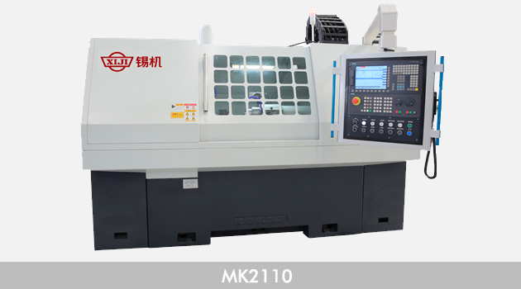
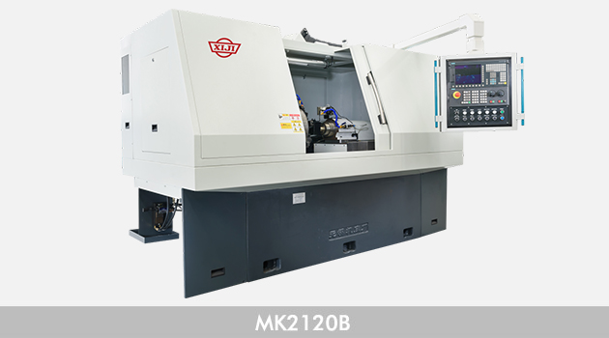
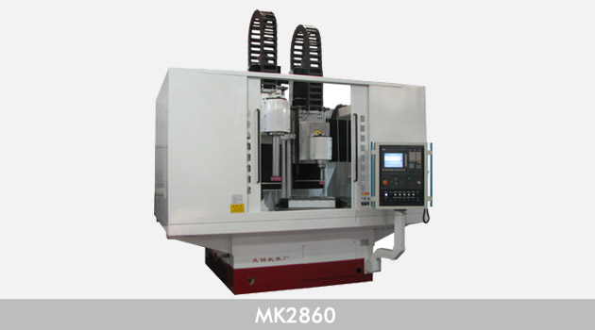
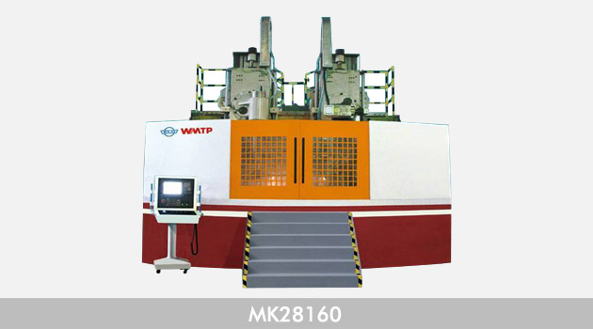
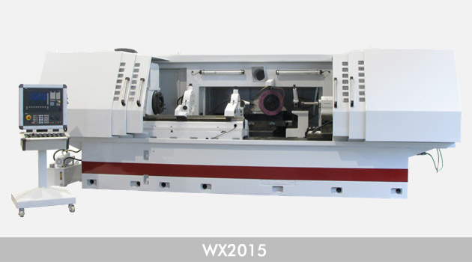
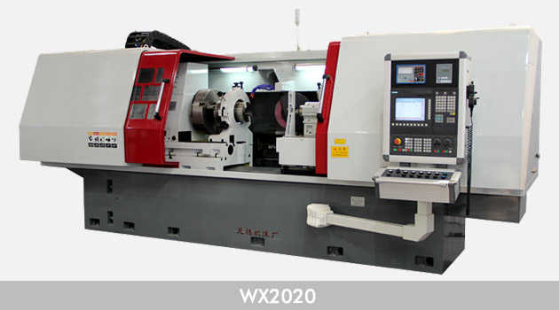
适用于各类套圈类、轴类零件的内孔（含锥孔、通孔或不通孔）的磨削。磨削孔径范围：3mm——500mm、300mm——2500mm（立式）;圆度范围：0.001m——0.008mm;直径一至范围：0.002mm——0.015mm;粗糙度范围：Ra0.016——Ra0.63;
产品型号 | 磨削孔径  (mm) | 磨削深度  (mm) | 最大工件旋径罩内/罩外  (mm) | 加工精度  (μm) |  |  | 总功率  (kw) | 机床重量  (kg) | 外形尺寸  (cm) | 备注
 |  |  |  | 圆度 | 圆柱度 | 粗糙度(Ra)
M215A | 3~50 | 80 | 180/220 | 3 | 3 | 0.63 | 5.59 | 1200 | 158×145×1
MD215A | 3~50 | 80 | 180/220 | 3 | 3 | 0.63 | 6.34 | 1300 | 158×145×1 | 带端磨
MB215A | 3~50 | 80 | 150/250 | 3 | 3 | 0.63 | 5.59 | 2350 | 290×165×1 | 半自动、数控
MBD215A | 3~50 | 80 | 150/250 | 3 | 3 | 0.63 | 6.34 | 2500 | 290×165×1 | 半自动、带端磨、数控
MB215B | 6~50 | 50 | 最大夹持100 最大旋径240 | 3 | 3 | 0.63 | 6.5 | 2500 | 200×109×1 | 半自动、数控
M215A/CNC | 3~50 | 80 | 180/220 | 2 | 3 | 0.63 | 10 | 1200 | 158×145×1 | 半自动、数控
MB215A/CNC | 3~50 | 80 | 150/250 | 2 | 3 | 0.63 | 8.8 | 2000 | 290×165×2 | 半自动、数控
MBD215B/CNC | 3~50 | 80 | 150/250 | 2 | 3 | 0.63 | 8.8 | 2500 | 290×165×2 | 半自动、带端磨、数控
M215B/CNC | 3~50 | 80 | 150/250 | 2 | 3 | 0.40 | 12 | 1600 | 206×135×1
MK215 | 6~50 | 80 | 最大夹持100 最大旋径240 | 1.2 | 2 | 0.40 | 20 | 2500 | 200×109×1 | 数控
M2110C | 6~100 | 150 | 260/480 | 3 | 5 | 0.63 | 4.14 | 1600 | 236×126×1
MBD2110B | 15~100 | 125 | 315 | 3 | 5 | 0.63 | 16 | 5000 | 260×250×2 | 半自动、带端磨、数控
MGD2110B | 10~100 | 125 | 240/400 | 1 | 2 | 0.08 | 7.5 | 3500 | 285×122×1 | 高精度、带端磨
M2110/CNC | 15~100 | 125 | 280/480 | 3 | 3 | 0.63 | 7.5 | 4000 | 260×148×1 | 数控
MK2110 | 15~100 | 125 | 400 | 2 | 3 | 0.40 | 25 | 4500 | 290×140×1 | 数控
MK2115 | 15~150 | 100 | 200/480 | 3 | 4 | 0.40 | 25 | 4500 | 290×140×1 | 数控
M2120A | 50~200 | 200 | 400/600 | 3 | 8 | 0.63 | 9.2 | 3400 | 310×213×1
MD2120A | 50~200 | 200 | 400/530 | 3 | 8 | 0.63 | 9.5 | 3500 | 310×213×1 | 带端磨
MB2120 | 50~200 | 150 | 400/600 | 3 | 5 | 0.63 | 9 | 3500 | 280×170×1 | 半自动、数控
MGD2120B | 50~200 | 200 | 400/600 | 1.5 | 3 | 0.16 | 9 | 4000 | 280×170×2 | 高精度、带端磨、数控
MK2120B | 30~200 | 150 | 400/600 | 2 | 4 | 0.40 | 25 | 5000 | 310×168×1 | 数控
M250A | 150~500 | 450 | 510/725 | 5 | 8 | 0.63 | 8.92 | 4500 | 379×165×1
MK2150 | 150~500 | 450 (Φ250~500) | 510/725 | 3(Φ150) | 5(Φ150) | 0.80 | 20 | 4500 | 400×185×1 | 数控
M2532C | 20~320 | 280 |  | 8 | 10 | 0.80 | 11.79 | 6500 | 201×141×3 | 立式行星磨床
MK2620 | 45~200 | 750 | 300 | 8 | 10 | 0.8 | 8 | 6000 | 512×170×1 | 数控深孔内圆磨
MK2710 | 30~100 | 80 | 400 | 2 | 3 | 0.40 | 10 | 5000 | 245×200×1 | 复合式数控
WX-004 | 15~100 | 180 | 220/350 | 径向跳动5 | 接触面90% | 0.32 | 4.2 | 3000 | 344×124×1 | 主轴锥孔磨床
WX-009A | 45~160 | 750 | 45-200 | 12 | 18/200 | 0.80 | 6 | 6000 | 512×170×1 | 深孔磨床
WX-031A | 35~135 | 80 | 500 |  |  | 0.80 | 6.7 | 2500 | 254×140×1 | 卡爪磨床
WX-034A | 160~250 | 50 | 夹具旋径540 | 10 | 20 | 0.80 | 9 | 6500 | 225×145×2 | 立式内圆磨床
WX-034C | 65~300 | 100 | 夹具旋径540 | 4 | 5 | 0.40 | 30 | 6500 | 145×240×3 | 数控立式内圆磨床
WX-042B | 4~6 | 20 |  | 0.8 | 2 | 0.16 | 5 | 3800 | 248×153×1 | 喷油嘴中孔座面磨床
WX-065 | 40~120 | 115(Φ40) 230(Φ120) |  | 跳动0.008/300 | 端面0.01 | 0.40 | 10 | 6500 | 465×283×1 | 主轴锥孔端面磨床
MK2860 | 150~600 | 500 | 800 | 4 | 8 | 0.4 | 50 | 20000 | 330×250×3 | 数控立式内圆磨床
MK28100 | 300~1000 | 500 | 1200 | 5 | 8 | 0.4 | 80 | 45000 | 510×310×5 | 数控立式内圆磨床
MK28160 | 400~1600 | 500 | 1700 | 5 | 8 | 0.4 | 90 | 50000 | 520×330×5 | 数控立式内圆磨床
MK28250 | 600~2500 | 500 | 2700 | 8 | 12 | 0.4 | 105 | 75000 | 680×570×5 | 数控立式内圆磨床

